**Viewz Adjustments:**

**For the whole website:**

1. Justify the text in all pages and sections please.
2. Decrease the font size
3. Reconsider the font types, we need something more elegant
4. The website is slow and lagging
5. The Parallax effect doesn’t work well
6. There is something wrong with the menu bar when you first open the website

**1: Edit the menu bar and fix the distance between the titles,** (make them smaller-same as the login size- and increase the distance between them)



**2: Decrease the text size it is so big and never use “All CAPS” to any section in the website.**

Note that the text will be shortened, and I will provide with it once I finish it.

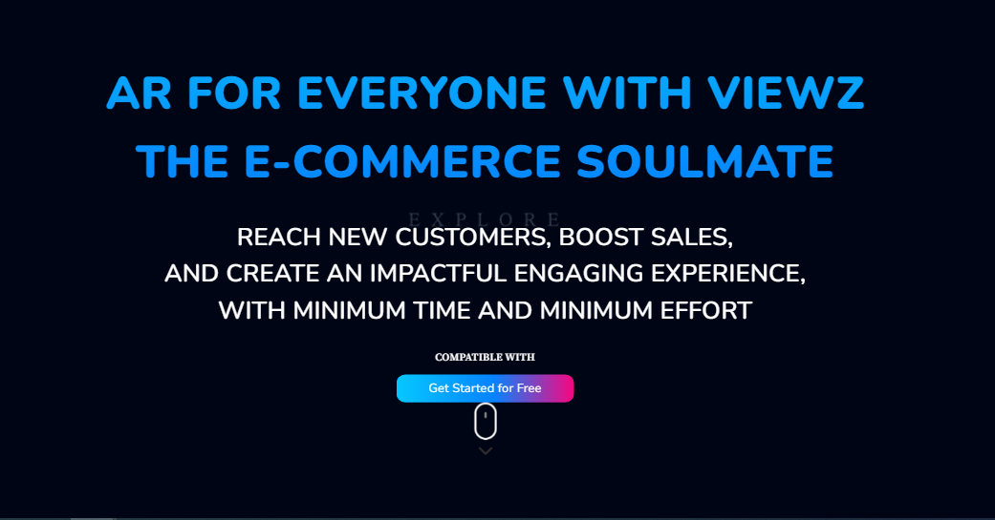

Double check for the positioning of this from your laptops.

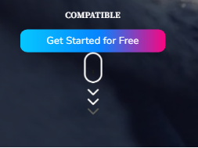

**3: Same here for the text,** it will be shortened and you should reconsider the font size



4: **Also here for the text;** and why the white BG still white? And once again make the images the same size, they don’t look good.

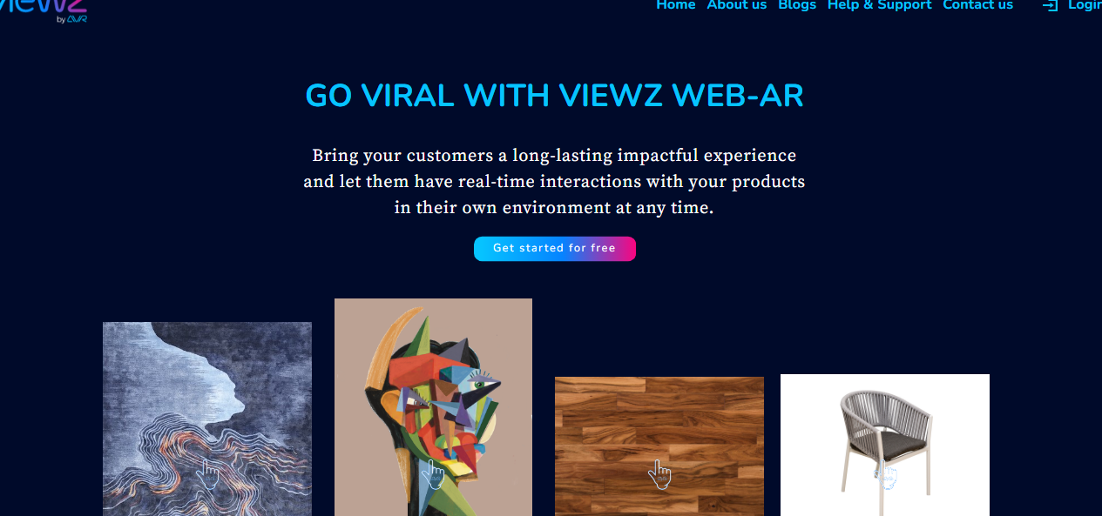

**5: same for the text:**

But here you need to change the items in the GIF, me and you Hanna will work on it

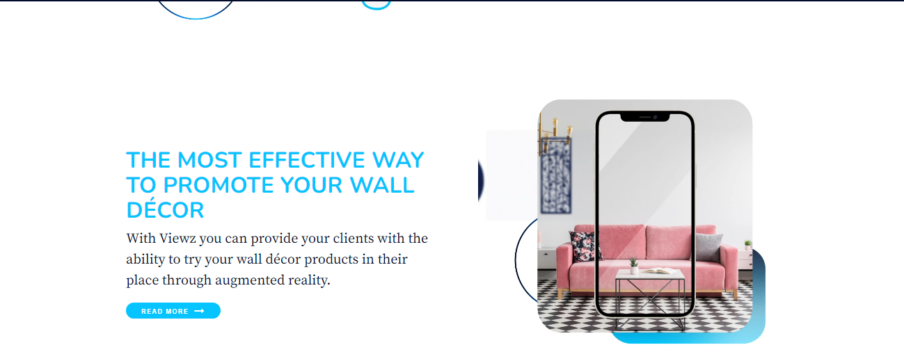

**6: same as mentioned above**

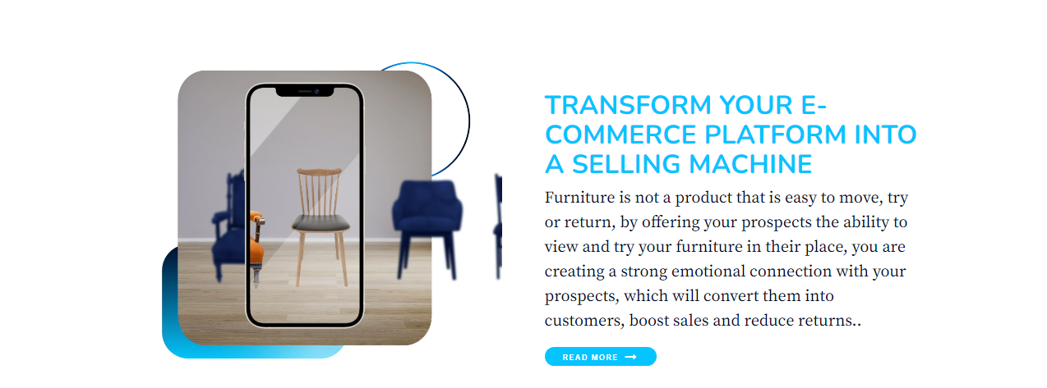

7: Add CTA here

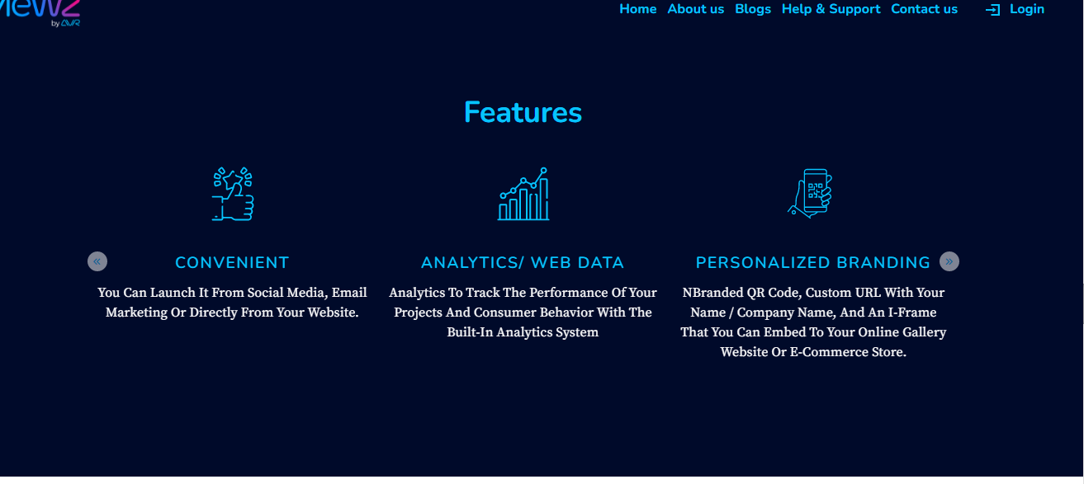

**8: the text color, position and style, all should be modified**

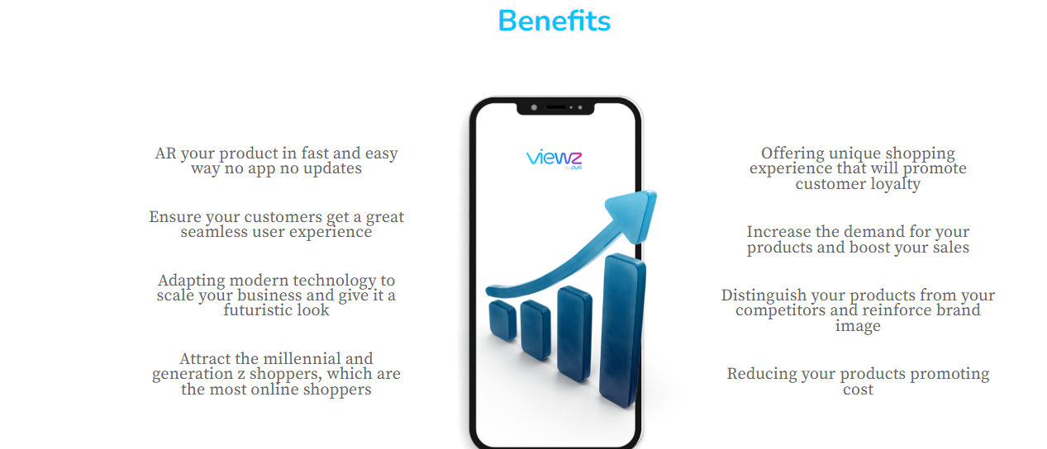

**9: the CTA button need to be more obvious; we will provide you with text and numbers**

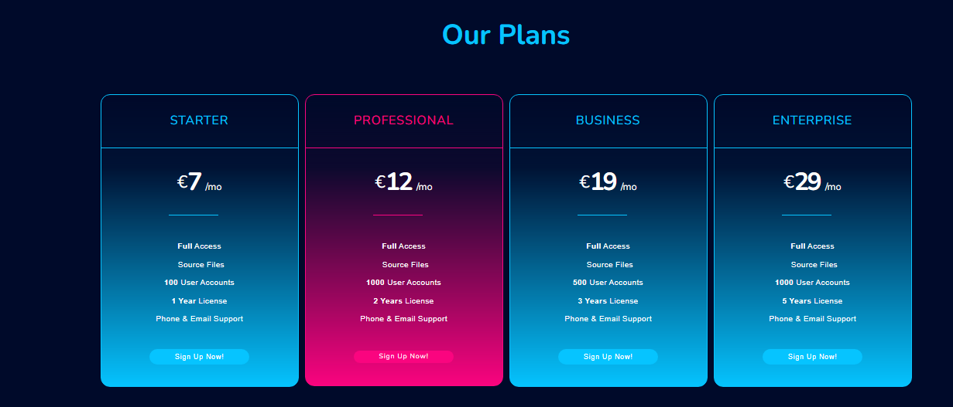

**10: too much shadow, lighten them and decrease their size**

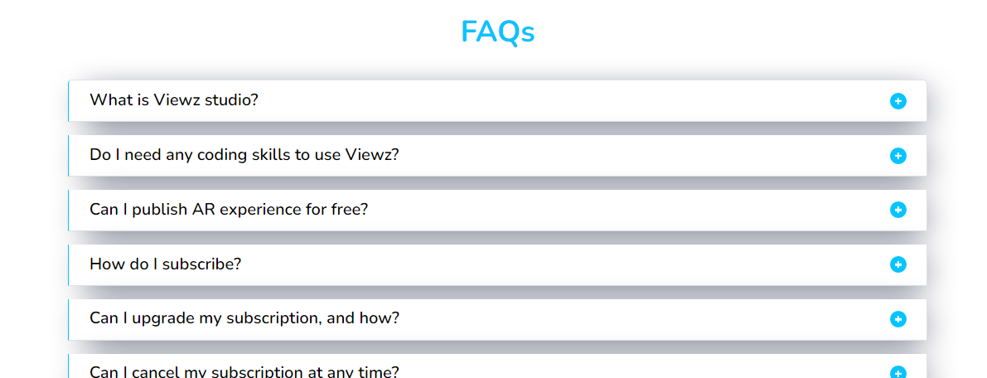

And justify the text:

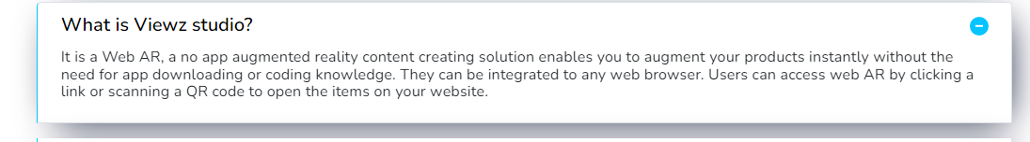

**11: justify the text at the about section,**

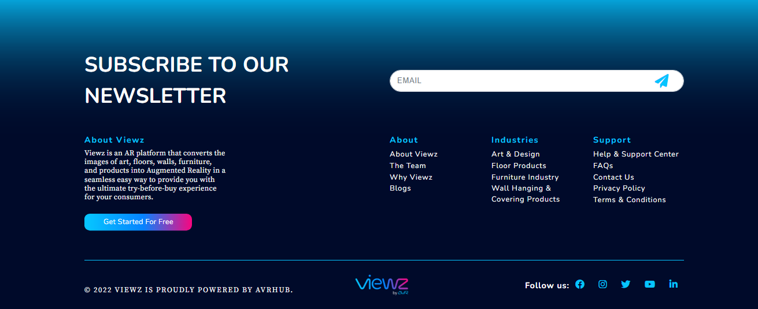

and never use “ALL CAPS”, edit this please “only normal sentence case”



**The about Page**

**1: Why this CTA is located here, check and fix please**

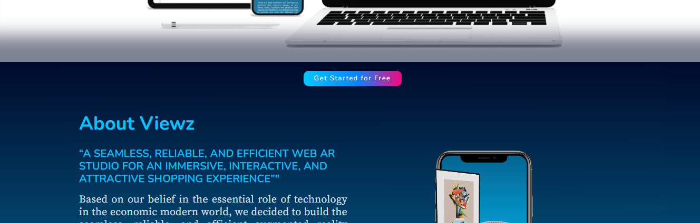

**2: Justify the text also, the text will be shortened,**

Make the image dimensions match the text, it is too small compared to it

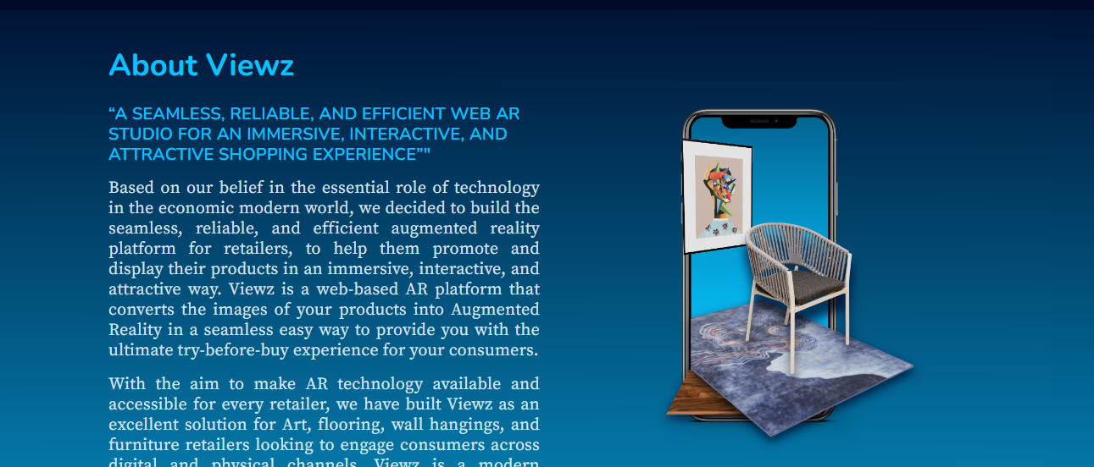

**3: here the text will be shortened**

The icons’ BG are not good change it to something better,

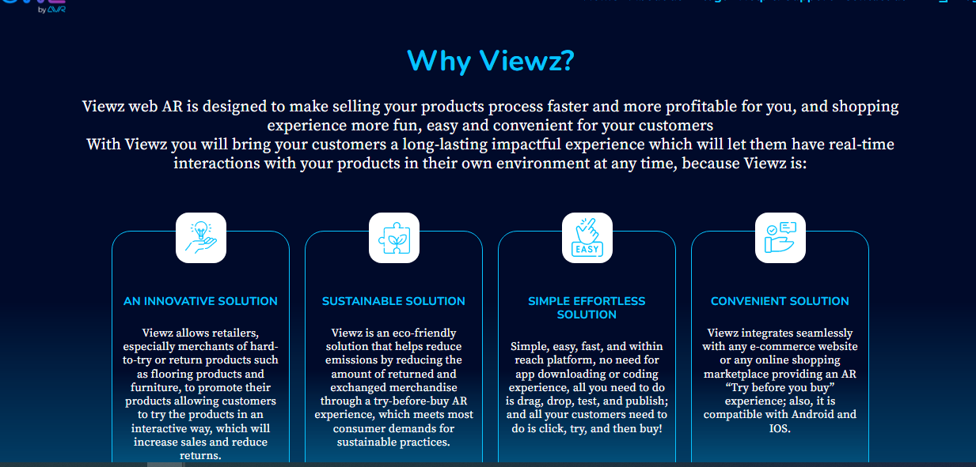

And add CTAs:

Get Started for Free Check our Plans



4: same for the text( justify and shorten), and move the icon above to be aligned with the title and without the dark blue BG

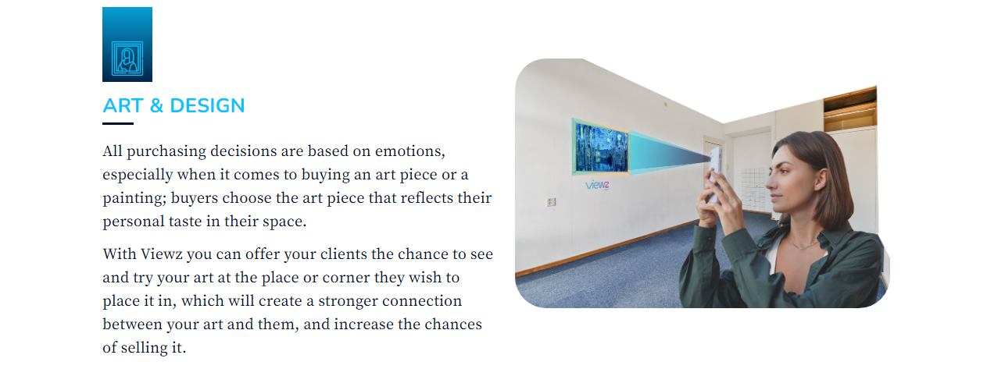

**5: modify the CTA and add the other one:**

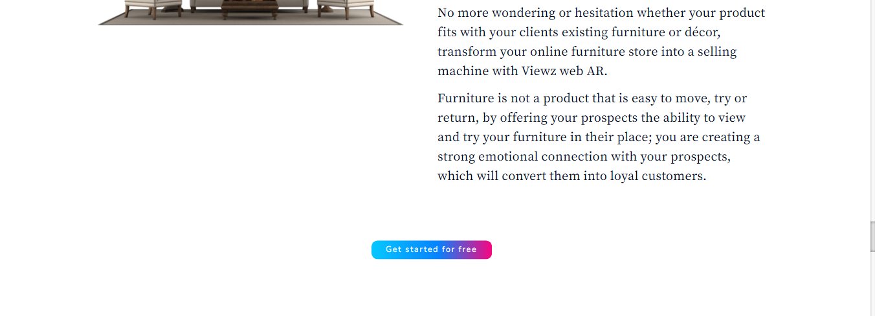

CTAs:

Get Started for Free Check our Plans



**6: remove this section parentally:**

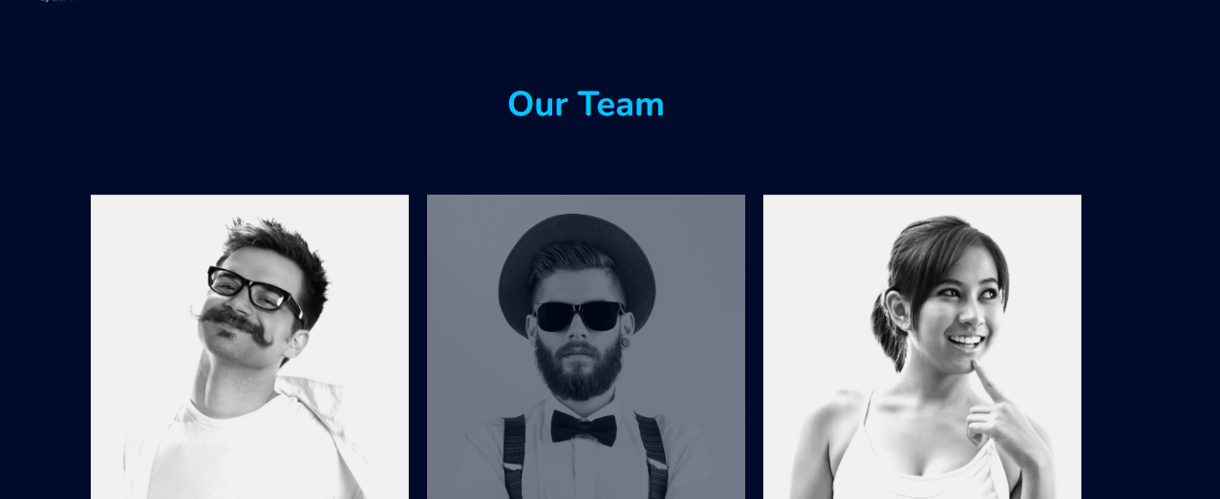

**The Blog Page:**

1: the parallax effect is not working, also the image and the text on it doesn’t look good at all, so remove it

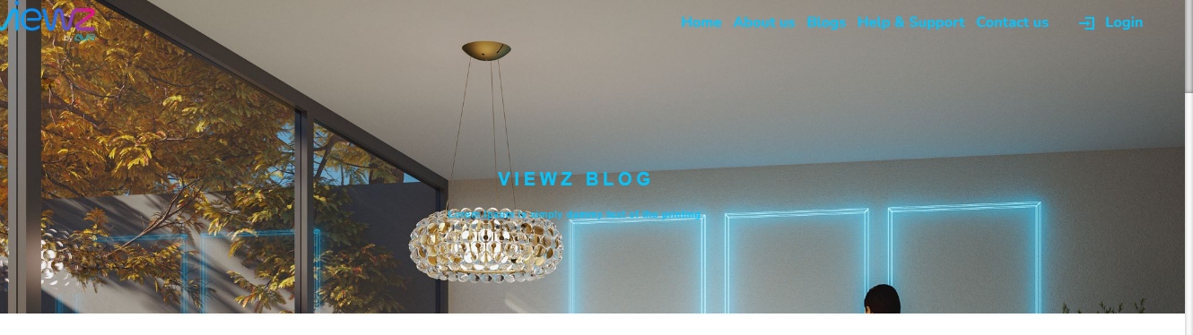

The help & support page:

1: same for the blog page: it is lagging, the text doesn’t look good, the shadow BG should be removed

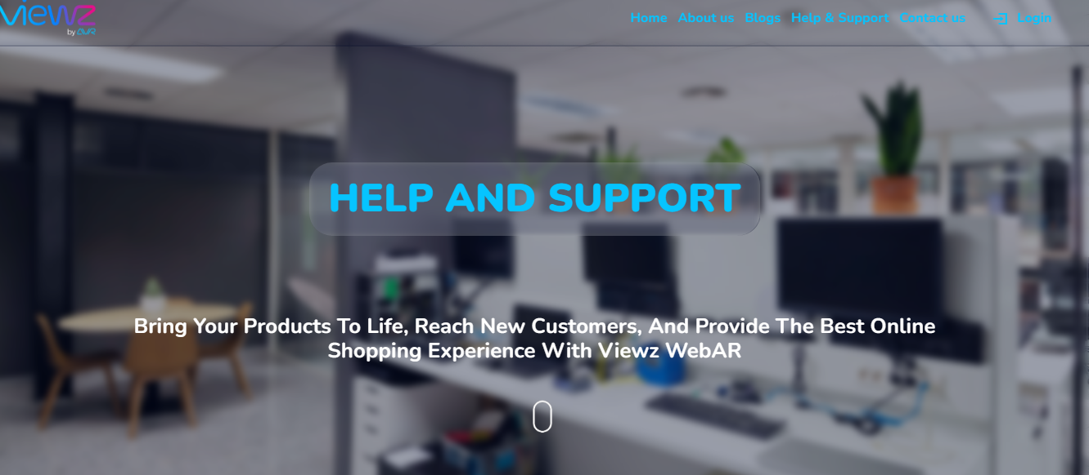

**The contact us page:**

1: we will change it all and make it similar to AVR website or check Amir’s website:

